Testing plan: Coursework 17/18 step 3

Designed and executed by B00329768 Mikolaj Lukasik on 13/04/2018.

Table of Contents

1. Batch information storage in json file 2

2. Listing of unallocated batches 3

3. Choosing the batch to allocate 4

4. Choosing the new location 5

# Batch information storage in json file

## Expected result:

On top of storing batch information in pickled file, program will now also store all needed info about the batch in BatchIndex.json file for faster indexing and search.

## Actual result:

BatchIndex.json is now a list of lists, which can be read according to this key:

0: batch ID

1: number of components

2: manufacture date

3: component type

4: component subtype

5: batch storage place

6: batch state

7: list of components

0: component id

1: component type

2: component subtype

3: component state

## Screenshots:

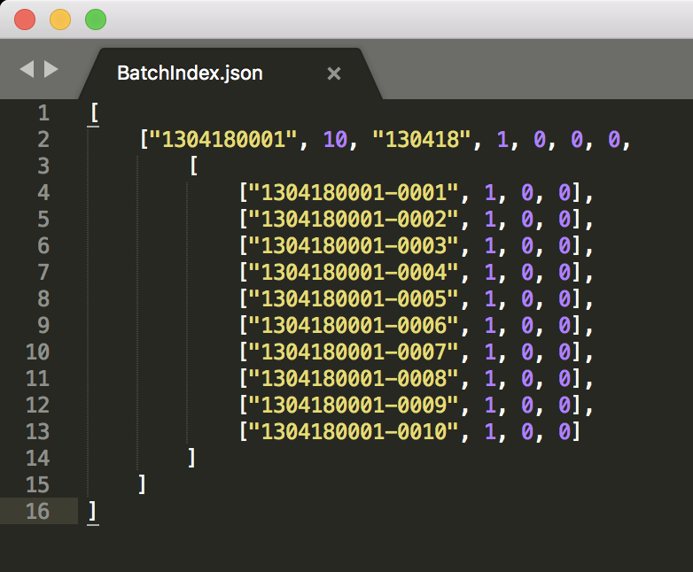

Disclaimer: screenshot formatted for readability.

# Listing of unallocated batches

## Expected result:

Choosing option 5 should list all batches that require allocation before allowing user to select them.

## Actual result:

If the program has batches that require allocation, program lists them line by line before letting user choose the correct batch (ss1). If all batches are already allocated, program shows the message “There are currently 0 batches that require allocation.”, and go back to main menu. (ss2)

## Screenshots:

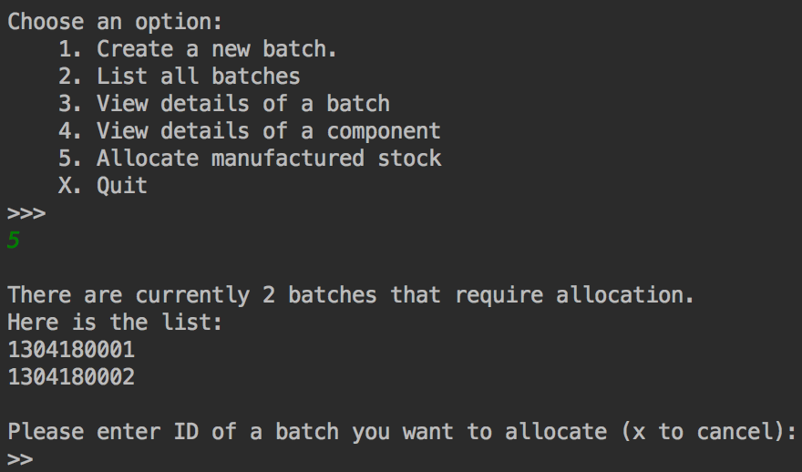

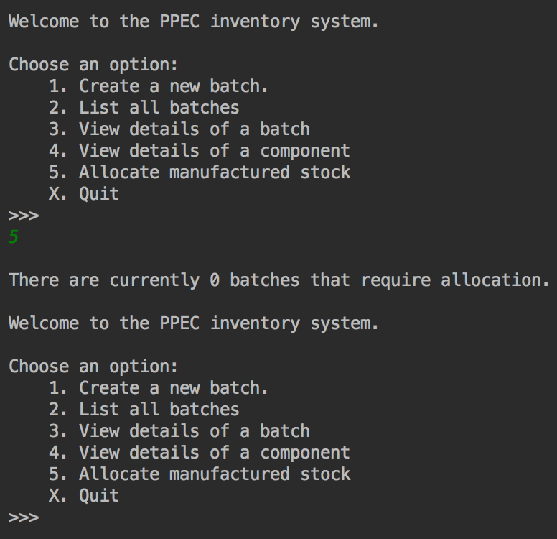

# Choosing the batch to allocate

## Expected result:

Providing the correct batch ID to allocate will allow user to move on to select the new place for batch storage.

## Actual result:

Retyping the batch ID from the “batches that require allocation” list will let user choose the allocation place. (ss1)

Incorrect batch ID, including all alphanumeric or multisymbolic input will result in error message. Same thing will happen if user enter the ID of a batch that have already been allocated. (ss2)

User can also go back to main menu simply selecting X. (ss3)

## Found bug:

Program does not differentiate between singular and multiple batches to allocate, always saying there are “batches” to allocate, even when there is only one.

## Screenshots:

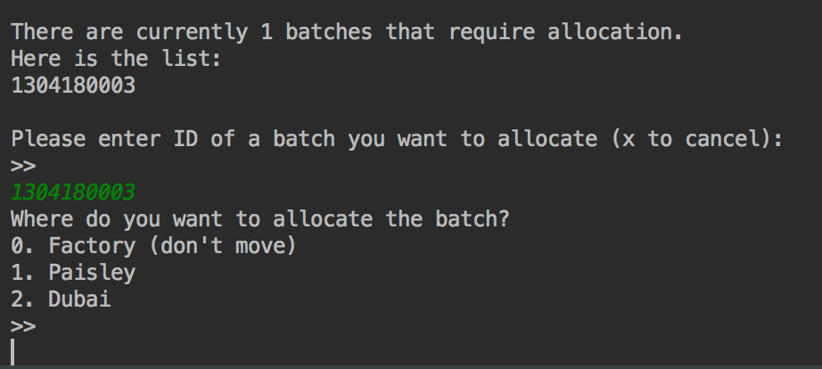

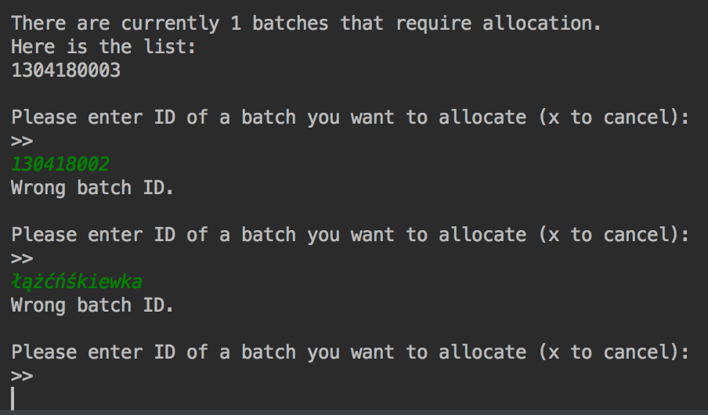

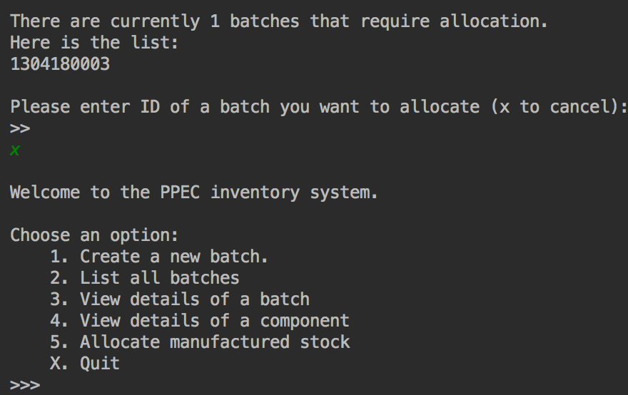

# Choosing the new location

## Expected result:

Providing the number corresponding with desired location will allocate the batch.

## Actual result:

User can choose not to move the batch by choosing 0. It will result in cancellation message and return user to main menu. (ss1)

Other numbers presented in option menu will properly allocate the batch to new location and display the confirmation message. (ss2)

Incorrect location input, including all alphanumeric or multisymbolic input will result in error message. (ss3)

## Screenshots:

